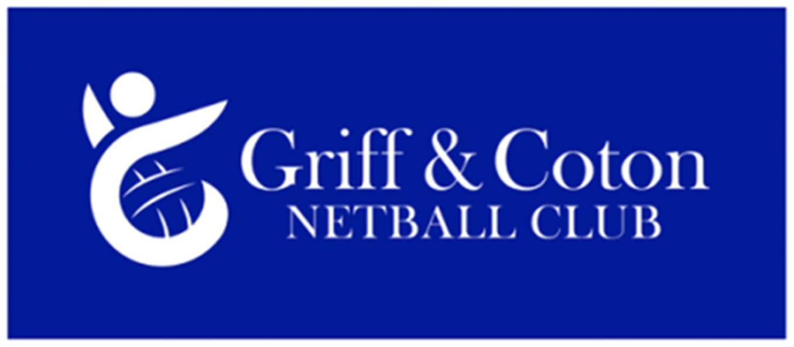

**JOB DESCRIPTION**

Marketing and Communications Officer

The Marketing and Communications Officer’s role is to manage all marketing, advertising and publicity for the for the Griff and Coton Netball Club (“Club”).

**WORKS WITH AND IS RESPONSIBLE TO**:-

* The Club’s Main Committee

**Purpose of the role**

* Ensure effective and regular communications with All Club members
* Utilise local media to ensure residents of Nuneaton and Bedworth and the local community are aware of the Club’s presence and activities
* Raise profile of the Club via online presence and any other relevant media
* Ensure online presence is accessible to all people searching to play netball for a local netball club
* Produce materials required for recruitment campaigns and events to increase membership

**Duties and Responsibilities**

* Raise profile of the Club via online presence and any other relevant media including the England Netball membership magazine
* Responsible for all Club Press Releases utilising contacts to gain publicity in the media (local, community and England netball publications) Produce and issue a minimum of four press releases each year
* Maintain and manage the Clubs Website ensuring it is kept fully up to date and accurate by posting relevant and current stories / updates / achievements about the club whilst sourcing and writing the content required
* Liaise with relevant club members to obtain information and / or ensure it is accurate and to update for the Club website
* Respond to messages and communications received via the website / Facebook page and if necessary highlight / forward to relevant committee member(s)
* Administrator for the Club’s Public Facebook page**,** ensuring The Facebook page is the “face” and public image of the Club and reflects the ethos of the club.
* Responsible for constructing relevant posts to assist with recruiting new players to the club and anything relating to the advertising the Club / netball / Griff and Coton sports club
* Monitor and review external postings made by 3rd parties (check posting is not offensive or inappropriate)
* Ensure the relevant permissions have been gained for photographs taken and published online, and social media adheres to the England Netball Social Media Policy
* Produce as and when required for posters/flyers for club events and recruitment campaigns, circulate to ensure they reach the appropriate target audience
* Assist with funding applications and provide any media / publicity as requested by funders
* Produce as and when required relevant marketing material
* Liaise with the Chair/Vice Chair regarding all external communications to a 3rd party
* Ensure all documentation is stored within GDPR guidelines (General Data Protection Regulation)
* Attend club committee meetings as necessary
* Represent the club at other external meetings for example netball league, Griff main committee /trustees/local council

**TIME COMMITMENT REQUIRED**

* Approximately 8-10 hours a month

**SKILLS/ATTRIBUTES REQUIRED**

* Excellent organisation and communication skills
* Some General Marketing experience
* Knowledge on how to update and maintain a website
* Ability to identify / generate topics/stories to write press releases
* Ability explore stories / topics online to update public Facebook page
* Ability to design and produce electronic posters / flyers
* Enjoy taking photographs and encourage others to do the same!
* Available to deal with correspondence during the day/early evening

**BENEFITS OF ROLE**

* Satisfaction of making a real contribution to the Club
* Platform for future volunteering/employment opportunities
* Meeting and working with new people within both the Club and externally with other organisations
* Improve Marketing and Communications skills